03年3月全国英语等级考试二级真题
第一部分听力
第一节听下面5段对话。每段对话后有一个小题，从题中所给的A.、B.、C. 三个选项中选出最佳选项，并标在试卷的相应位置。听完每段对话后，你都有10秒钟的时阅读下一小题。每段对话仅读一遍。
例如，你将听到以下内容：
M:Excuse me.Can you tell me how much the shirt is?
W：Yes，it’s nine fifteen.
请看选项：
How much is the shirt?
A. ￡19.15.
B. ￡9.15.
C. ￡9.18.
衬衫的价格为9镑15便士，所以你选择B. 项，并在试卷上将其标出。
Answer:A.
B.■C.
1. Where are they talking?
A.In a post office. B.In a restaurant. C.In a bank.
2. What does the man want to do?
A.To have tea. B.To see father. C.To talk to Ella.
3. For whom is tea and coffee?
A.Lucy. B.The man himself.C.Some guests.
4. What are the two speakers talking about?
A.A tea house. B.A hotel. C.A restaurant.
5. What’s the man going to do?
A.Buy some bread. B.Go back home. C.Ask for directions.
第二节听下面5段对话或独白。每段对话或独白后有几个小题，从题中所给的A.、B.、C. 三个选项中选出最佳选项，并标在试卷的相应位置。听每段对话或独白前，你将有5秒钟的时间阅读各个小题；听完后，各小题将给出5秒钟的作答时间。每段对话或独白读两遍。
听第6段材料，回答第6~7题。
6. When does this conversation take place?
A.In the middle of a vacation. B.At the end of a term. C.Before the exams.
7. Where do the speakers plan to go?
A.To a concert. B.To a party. C.To a film.
听第7段材料，回答第8~10题。
8. According to the man, what is so special about the Art Museum?
A.It’s the biggest museum in the world.
B.It’s famous paintings.
C.It’s near the National Park.
9. Where was the woman yesterday?
A.In the Art Museum. B.In the National Park. C.In the Science Museum.
10. What did the woman invite the man to do?
A.Have dinner with her. B.Go to the National Park.
C.Visit the Science Museum.
听第8段材料，回答第11~13题。
11. Where are the speakers?
A.At the airport. B.At the railway station. C.At the bus station.
12. What is the weather like?
A.It’s snowing. B.It’s sunny. C.It’s raining.
13. Where are they going?
A.Washington. B.Paris. C.London.
听第9段材料，回答第14~16题。
14. Where does probably take place?
A.On a plane. B.At a gettogether. C.In an English class.
15. How long has the woman planned to stay in England?
A.Two weeks. B.Ten weeks. C.Twelve weeks.
16. What is the woman’s native language?
A.English. B.French. C.German.
听第10段材料，回答第17~20题。
17. What does the girl want to do at Christmas?
A.To dance. B.To act in a play. C.To play football.
18. Why does the girl like computer science?
A.She finds it easy to learn.
B.She has a computer shop.
C.Her father has taught her about it.
19. What do we know about the girl’s mother?
A.She is a hospital worker.
B.She works on a farm.
C.She enjoys her job.
20. Why is it important for the girl to have Sunrise Dance?
A.It’s her first time to dance.
B.She will become a grownup.
C.Everyone will come and watch.
第二部分英语知识运用
第一节单项填空
从A.、B.、C.和D.四个选项中，选出可以填入空白处的最佳选项，并在答题卡1上将该项涂黑。
Example:
It is generally considered child he or she wants.
A. however B. whateverC. whicheverD. whenever
Answer：A.
B.■C. D.
21.You’re always late. You late three times this week.
A.are being B. were C.had been D.have been
22.What was the matter with you this morning? you looked you hadn’t slept for the last twentyfour hours.
A.so as B. that C.as if D.like that
23.— Please don’t tell anybody.
— I , I promise.
A.can’t B. don’t C.won’t D.mustn’t
24.Helen looked at the finished painting with .
A.satisfaction B. success C.victory D.favour
25.At 13 he was sent to a shop, he learned the business.
A.when B. which C.where D.that
26.Susan is nearly thirtyfive. Her parents think it’s time she married.
A.would get B. gets C.will get D.got
27.The room contained equipment including several TV monitors.
A.little B. a few C.a number of D.a lot of
28.— Can you speak Russian?
— I can speak a little I can’t understand much.
A.and B. but C.otherwise D.or
29.If it rains, we should not go out, but the sky perfectly clear.
A.isB. will be
C.wasD.had been
30.We must finish the job, no matter difficult it is.
A.however B. how C.whatever D.what
31.— Have you got any idea for the summer vacation?
— I don’t mind where we go there’s sun, sea and beach.
A.as if B. if only C.now that D.as long as
32.I’ve decided to your advice and stop smoking for good.
A.take B. receive C.believe D.consider
33.When you stay in a foreign country for some time, you get used to the people’s of life.
A.way B. habit C.rule D.fact
34.— Professor Brown looks sad today.
— He is sad. Yesterday a fire house and his dog got .
A.burnt B. to burn C.burning D.to be burnt
35.It isn’t David says that annoys me but the way he says it.
A.how B. that C.what D.why
第二节完形填空
阅读下面短文，从短文后所给各题的四个选项(A.、B.、C.和D.)中选出能填佳选项，并在答题卡1上将该项涂黑。
I usually don’t take the subway(地铁) to get to my office, but it’s a good thing I did last Tuesday. I 36 a man sitting opposite me who 37 to be extremely nervous. He was 38 wideeyed at one of (广告) in the car. Then his hands started to 39. I took my medical bag and 40 to him.
“Well, what 41 seems to be wrong with you?” I asked.
He pointed at an advertisement 42 the good qualities of a 43 kind of shirt. It 44:“It will not wilt, shrink, crease, or wrinkle.”
“Well, 45 about it?”
“I’m going 46,” he said. “I can read it to myself, but I can’t says it out 47.”
“My dear man,” I comforted him, “you can say it. Of course you can. You’re 48 a little nervous. This is just a nervous attack. You must not 49. You it. Now say it.”
“It...it will not wilt, crink, wack, or shrinkle,” he said, and with a groan(呻吟) he 50 his face with his hands.
“Now come. 51 me,” I told him, “and learn how perfectly simple the whole 52 is.” I continued in a firm voice:“It will not wink, shink, wack, or cinkle.” Oh, my！ I 53 several times, each was wrong in a different way.
The man 54, and appeared completely recovered. I was 55. The man was cured. Of course, I had an act.
36.A.cured B.met C.taught D.noticed
37.A.turned B.appeared C.pretended D.meant
38.A.admiring B.screaming C.pointing D.staring
39.A.move B.shake C.touch D.wave
40.A.came back B.went on C.rushed over D.looked over
41.A.generally B.exactly C.usually D.naturally
42.A.telling about B.showing off C.calling forD.dealing with
43.A.common B.regular C.famous D.certain
44.A.admitted B.said C.proved D.called
45.A.what B.how C.talk D.think
46.A.crazy B.ahead C.angry D.back
47.A.loud B.alone C.freely D.completely
48.A.truly B.really C.simply D.particularly
49.A.stop B.give in C.hurry up D.look
50.A.covered B.turned C.hid D.touched
51.A.Talk to B.Allow C.Listen to D.Show
52.A.advertisement B.problem C.situation D.thing
53.A.tried B.spelled C.spoke D.explained
54.A.was anxious B.was nervous C.laughed D.shouted
55.A.interested B.delighted C.worried D.astonished
第三部分阅读理解
阅读下列短文，从每题所给的四个选项(A.、B.、C.和D.)中选出最佳选项，并在答题卡1上将该项涂黑。
A
Ann Curry is a famous news presenter of the NBC News “Today” show. When she was 15 she happened to walk into a bookstore in her hometown and began looking at the books on the shelves. The man behind the counter, Mac McCarley, asked if she’d like a job. She needed to start saving for college, so she said yes.
Ann worked after school and during summer vacations, and the job helped pay for her first year of college. During college she would do many other jobs: she served coffee in the student union(学生会), was a hotel maid and even made maps for the U.S. Forest Service. But selling books was one of the most satisfying jobs.
One day a woman came into the bookstore and asked Ann for books on cancer(癌症). The woman seemed anxious. Ann showed her practically everything they had and found other books they could order. The less worried, and Ann has always remembered the pride she felt in having helped her customer.
Years later, as a television reporter in Los Angeles, Ann heard about a child who was born with problems with his fingers and his hand. His family could not afford a surgical(外科的) operation, and the boy lived in shame, hiding his hand in his pocket all the time.
Ann persuaded her boss to let her do the story. After the story was broadcast, a doctor and a nurse called, offering to perform the surgical operation for free.
Ann visited the boy in the recovery room after the operation. The first thing he did was to hold up his repaired hand and say, “Thank you.” What a sweet sense of satisfaction Ann Curry felt!
At McCarely’s bookstore, Ann always sensed she was working for the customers, not the store. Today it’s the same. NBC News pays her, but she feels as if she works for the people who watch the programmes, helping them make sense of the world.
56.Ann Curry got her first job .
A.from her friend in a bookstoreB.a couple of years before college
C.at the NBC news “Today” showD.when she was studying at university
57.At which parttime job did Ann Curry feel the happiest?
A.The hotel.B.The bookstore.
C.The student union.D.The US Forest Service.
58.What particularly gives her the feeling of pride?
A.Helping people through work.B.Reporting interesting stories.
C.Being able to do different jobs well.
D.Paying through her college education.
59.How did Ann help the child get the operation he needed?
A.Ann persuaded the boy to speak on TV.
B.Ann paid for the operation herself.
C.Ann’s boss agreed to raise money.
D.Ann’s news report moved some doctors.
B
Last April, on a visit to the new Mall of America near Minneapolis, I carrid book provided for the reporters by the public relations office. It included a variety of “fun facts” about the mall, such as:140 000 hot dogs are sold each week, there are 10 000 fulltime jobs, 44 sets of moving stairs and 17 lifts, 12 750 parking places, 13 000 tons of steel, and ＄1 million is drawn weekly from 8 ATMs. Opened in the summer of 1992, the mall was built where the former Minneapolis Stadium(体育馆) had been. It was only a fiveminute drive from the MinneapolisSt. Paul International Airport. With 4.2 million square feet of floor space — twentytwo times the size of the average American shopping center — the Mall of America was the largest shopping and family recreation(娱乐)center under one roof in the United States.
I knew already that the Mall of America had been imagined by its designers, not merely as a marketplace, but as a national tourist attraction. Eleven thousand articles, the small book informed me, had been written about the mall. Four hundred trees had been planted in its gardens, ＄625 million had been spent to build it, and 350 stores were already in business. Three thousand bus tours were expected each year along with a halfmillion Canadian visitors and 200 000 Japanese tourists. Sales were expected to be at ＄650 million for 1993 and at ＄1 billion for 1996. Pop singers and film stars such as Janet Jackson and Arnold Schwarzenegger had visited the mall. It was five times larger than Red Square and it included 2.3 miles of hallways and used almost twice as much steel as the Eiffel Tower. It was also home to the nation’s largest indoor park, called Knott’s Camp Snoopy.
60.We know from the text that the Mall of America is .
A.near an old stadiumB.close to an airport
C.higher than the Eiffel TowerD.bigger than most America parks
61.Why are the pieces of information provided by Mall of America referred to as “fun facts”?
A.They are largely imagined.B.They are surprising figures.
C.They give exact descriptions.D.They make people feel uneasy.
62.What’s the point of mentioning popular stars who had been to the mall?
A.To show its power of attraction.
B.To show that few rich people like to shop there.
C.To tell the public about a new movie being made about it.
D.To tell people that of meeting famous stars there.
63.We can infer from the text that .
A.Japanese visitors are most welcome to the mall
B.Canadian visitors would spend ＄1 billion at the mall
C.Knott’s Camp Snoopy was next to the Mall of America
D.the Mall of America was designed to serve more than one purpose
C
The research was done by a Dr. Griffiths in England. He compared the behavior of 15 regular gamblers(赌徒) with those of 15 nonregular gamblers before and after they gambled. Both groups had increased heart rates(心率) during gambling because it was exciting. But the regular gamblers’ heart rates went down almost straight after the game, while the nonregulars remained excited and had increased heart rates for longer.
When the heart beat increases, the body produces chemicals called endorphins which make you feel good. Dr. Griffiths thinks that regular gamblers lose this good feeling soon after a game and need to play again quickly to regain the pleasure.
He has also discovered that regular gamblers have different psychological reactions(心理反应) from nonregular gamblers. In an experiment where regular and nonregular gamblers thought aloud while playing, regular gamblers had far more unreasonable thoughts. In their minds they turned losses into nearwins. Dr. Griffiths thinks that nearly winning gives the gambler a high in the same way that a win would do.
Based on Dr. Griffiths’ research, doctors suggest that one way to help regular gamblers to give up gambling is to give them betablockers — drugs that stop them getting a high in the first place.
64.Dr. Griffiths’ research helps you find out .
A.which group of gamblers played the game better
B.a chemical to increase gamblers’ heart beat
C.a way to up gambling
D.when gamblers should be given drugs
65.How did Dr. Griffiths discover the gamblers’feelings when winning and losing?
A.By examining the different chemicals in gamblers’bodies.
B.By asking the gamblers to speak aloud their feelings.
C.By asking the gamblers to discuss their ideas.
D.By testing the gamblers’heart beat.
66.The underlined words “a high” probably mean “”.
A.a feeling of happinessB.a reasonable thought
C.a great expectationD.an exciting idea
67.According to the text, what do we know about nonregular gamblers?
A.Their bodies produce less endorphins during the game.
B.They don’t consider losses in a game as reasonable nearwins.
C.Their bodies have no reaction to beta blockers.
D.They have faster heart rates during the game.
D
It was probably around 3 000 years ago that people first began making measure the passage of time. Having noticed that shadows move around trees as the sun moves across the sky, someone drew a circle and put a stick in the center. As the sun passed overhead, people could tell which part of the day it was by noticing which mark on the circle the shadow fell across. These circles were called “sundials”. Later, they were made of stone and metal to last longer.
Of course, a sundial did not work at night or on cloudy days, so men kept inventing(发明) other ways to keep track of time. After glass blowing was invented, the hourglass came into use. An hourglass is a glass container for measuring time in which sand moves slowly from the top half to the bottom in exactly one hour. The hourglass is turned over every hour so the sand could flow again.
One of the first clocks with a face and an hour hand was built for a king of France and placed in the tower of his palace. The clock did not show minutes or seconds. Since there were no planes or trains to catch, people were not worried about knowing the exact time. Gradually, clocks began to be popular and unusual. One clock was in the shape of a cart with a horse and driver. One of the wheels was the face of the clock.
Today, scientists have invented clocks that tell the correct time to a split second. Many electric clocks are often made with builtin radios, which can sometimes be set to turn on automatically(自动地). Thus, instead of an alarm(闹铃) ringing in your ear, you can hear soft music playing when it is time to get up. Some clocks will even start the coffee maker!
68.In the first paragraph, the word “sundial” refers to .
A.the shadow of the sun B.the circle on the ground
C.a tool to carry stones D.a timekeeper
69.In what way was the hourglass better than the sundial?
A.It could be used under any weather conditions.
B.It could be turned over and over again.
C.It was made of glass. D.It could last longer.
70.Besides telling the time, a modern electric clock can .
A.answer phone calls B.say your name
C.start a small machine D.cook different food
71.What is the passage?
A.Clocks of Our Lives B.What Can a Clock Tell Us
C.Clock through Time D.Clocks Change People’s Lives
E
“When one of the doctors criticizes(批评) me, I get defensive. I feel like a child again, being scolded, and that I’m not wrong.” says Viola, a nurse. This is a common reaction(反应) to criticism, but not a good one. There are better ways of dealing with criticism.
1.Try to be objective(客观). When Sol was criticized by his new employer for not having made a sale, Sol’s reaction was to feel sorry for himself. “I had put everything I had into making that sale,” Sol says, “and I felt that I had failed as a person. I had to learn through experience not to react like that to each failure.”
2.Take time to cool down. Rather than reacting immediately to criticism, take some time to think over what was said. Your first question should be whether the criticism is fair from the other person’s position. The problem may be a simple misunderstanding of what you did or your reasons for doing it.
3.Take positive(积极的) action. After you cool down, consider what you can do about the situation. The best answer may be “nothing.” “I finally realized that my boss was having personal problems and taking them out on me because I was there,” says Sheila. “His criticisms didn’t really have anything to do with my work, so nothing I said or did was going to change them.” In Sheila’s case, the best way to deal with it was to leave her job. However, that’s an extreme reaction. You may simply explain your opinion without expecting an indepth discussion. You may even decide that the battle isn’t worth fighting this time. The key, in any case, is to have a reasonable plan.
72.When Sol was criticized by his employer, he .
A.argued bitterly with his employer
B.was angry and gave up his job
C.was sorry for what he did
D.was sad and self pitying
73.According to the writer, you should take time to think about criticism because .
A.people may have a mistaken idea of what you did
B.you other people’s opinions
C.people may discuss it with you in depth
D.you need time to understand yourself
74.When the writer says that “the best answer may be ‘nothing’”, he means you may decide .
A.to take no notice of the criticismB.to argue with your boss
C.you need to change your jobD.you’ve done nothing wrong
75.The writer thinks Sheila can decide to leave her job because her boss .
A.didn’t like her appearance
B.refused to change his opinion
C.made an unreasonable criticism
D.refused to talk to her about the criticism
第四部分写作
第一节短文改错
此题要错误。对标有题号的每一行做出判断：如无错误，在该行右边横线上画一个勾(√)；如有错误(每行只有一个错误)，则按下列情况改正：
多一个词：把多余的词用斜线(＼)划掉，在该行右边横线上写出该词，并也用斜线划掉。
缺一个词：在缺词处加一个漏字符号(∧)，在该行右边横线上写出该加的词。
错一个词：在错的词下划一横线，在该行右边横线上写出改正后的词。
注意：原行没有错的不要改。
Dear Hilda,
I’ve just heard of my mother has suddenly been 76.
taken ill, and I’d like to go and see what she is.The 77.
trouble is that I can take him with me then.78.
Do you think if you would possibly able to look after 79.
him for a week? You have him for a week last year, 80.
and you said he had been no trouble, but had got 81.
on well with your little sister, Jane.82.
If I could have him, I would be able to bring 83.
him along any time that suits for you.But if it is not 84.
convenient, do hesitate to say so.85.
Yours,
Sarah
第二节书面表达
假定你是李明，你的英国朋友Dave与你在同一个城市工作。你去邀请他和你展。他不在，请你根据以下要点给他写个留言条。
要点：
1.介绍画展
中国画
历代名画展
展期：本月8日——18日
地点：艺术博物馆
2.约定会面的地点和时间
注意：词数80～100。
03年9月全国英语等级考试二级真题
笔试部分答题时间：100分钟
姓名： 准考证号：
第一部分 听力 1～20略
第二部分英语知识运用
第一节单项填空
从A、B、C和D四个选项中，选出可以填入空白处的最佳选项，并在答题卡l上将该项涂黑.
21. －Why didn' t you answer the phone this afternoon?
－We didn' t hear it. I was and Mum __________ a shower.
A.has had B.had C.had been having D.was having
22. Laura had a good reason __________ to class yesterday.
A.for not going B.to not go
C.for going not D.to go not
23. The further away you go out from the city, __________ are the scenes.
A.the much attractive B.the attractive
C.the most attractive D.the more attractive
24. We don't have much time __________ ; I will end my lecture in minute.
A.remained B.left C.kept D.found
25. －Where is my blue shirt?
－It' s in the washing machine. You have to wear __________ different shirt.
A.any B.other C.a D.the
26. You look tired; you __________ have stayed up late last night.
A.must B.should C.would D.may
27. I don' t think each other, __________ ?
A.do you B.don' t you C do I D.don't I
28. People in this town __________ of a possible storm, and they' re preparing for it.
A.would be warned B.will be warned
C.had been warned D.have been warned
29. David had been there for nearly an hour. He didn' t know __________ to wait or go home.
A.if B.neither C.whether D.either
30. What' s done is done. It' s no use __________ anyone for it.
A.blaming B.blame C.to blame D.to be blaming
31. Customers are found to be more satisfied __________ the quality of the goods than their service.
A.about B.at C.by D.with
32. －What we use for the Japanese students?
－That is another question __________ we' ll discuss later.
A.what B.about which C.on that D.which
33. Since the middle of this century __________ has been learned about space than in all human history before that time.
A.more B.much C.better D.a lot
34. After recovering from his illness, he was very anxious to __________ his work.
A.get down B.get through
C.get back to D.get along with
35. I checked all my answers __________ my teacher had suggested.
A.as to B.as C.that D.such
第二节 完形填空
阅读下面短文，从短文后所给各题的四个选项(A、B、C和D)中选出能填入相应空白处的最佳选项，并在答题卡上将该项涂黑.
" $ 160 for a parking ticket! I' m calling city hall about this. There mistake."Nick thought 36 "Yes, sir, there is a mistake," said the man at the city hall, " 37 I'm afraid the mitake' s 38 This ticket was for $ 20. However, the fine doubles every thirty days. It has been 90 days, so the 39 is now $ 160. You will have to pay that. " Nick had the $ 20 and he 40 to pay the fine. But for some reason the ticket had gotten 41 in his pile of papers and unopened letters.
Nick has always been a 42 person. In the past six months, he had 43 to bill, 44 his jacket at the cleaner' s too 45 and had to pay for the "storage(保管) ".A job application (申请) form he had filled out was never 46 because it, too, was in one of his piles. "Get organized, man,"his brother advised. "Plan what you 47 do, do it, and then 48 to be sure you' ve done it right. "
Nick got a calendar ( 日历) with enough 49 to write on. He marked important 50 and times as reminders. "Nice job, "said his brother. "Now 51 you do what you' re supposed to do 52 you' re supposed to. " "That shouldn' t be too 53 with my calendar here, "said Nick. "And read on it 54 you get a ticket," added his brother. "Or 55 still, don't get another. "
36. A. happily B. angrily C. disappointedly D. excitedly
37. A. so B. luckily C. honestly D. but
38. A. mine B. yours C. ours D. theirs
39. A. number B. pay C. cost D. total
40. A. forgot B. meant C. refused D. remembered
41. A. missed B. covered C. mixed D. buried
42. A. patient B. careless C. wasteful D. tough
43. A. forgotten B. required C. regretted D. considered
44. A. left B. sent C. bought D. washed
45. A. long B. late C. often D. early
46. A. mailed B.recorded C. taken D. received
47. A. have to B. used to C. would D. could
48. A. see B. check C. examine D. make
49. A. area B. square C. place D. space
50. A. accidents B. events C. dates D. weeks
51. A. take care B.believe in C.watch out D. make sure
52. A. where B. since C. when D. that
53. A. late B. bad C. much D. hard
54. A. as B. next time C. since D. so long as
55. A. fairer B. easier C. better D. happier
第三部分阅读理解
阅读下列短文，从每题所给的四个选项(A、B、C和D)中，选出最佳答案，并在答题卡上将该项涂黑.
第一篇
It was 7 a.m. in Kyoto, Japan, and the taxi company had just called a second time to say they couldn' t find my house. Once again I spelt out directions even a blind person could follow, I glanced impatiently at my watch, and waited. Only two hours remained until my flight left and it was an hour-and-a-half trip to the airport.
Outside, heavy rains were pouring down. My house was so far north in the city that buses pass only three times a day.
The telephone rang again. "Terribly sorry," began the man at the taxi company. Then I rea-lized that the taxi company, flooded with calls, could runs. I had heard this happens when the weather gets bad. I shouted into the phone that I had a plane to catch and I would meet the taxi outside my house.
Standing in the wind-driven rain, I looked up and down the road. No taxi. A car went by, driver and passenger staring at the crazy foreigner in the downpour. Finally a white car appeared and pulled to a stop. A young man threw open the door, waving for me to get in. Shaking with cold and anger, I climbed in.
In the most polite Japanese, the man said he was called Mike, with whom I had spoken three times that morning. He had left his post in the office and raced here in his personal car. He apologized again, but did not explain why a taxi would not pick me up. Delivering me straight to the airport, he refused the 2000 yen I pressed into his hand.
A few hours later, as the storm-delayed 727 took off, I opened the newspaper. On the second page my eyes caught the headline of a short article:" Taxi Strike Begins This Morning in Kyoto."
56. Why did the writer call a taxi early in the morning?
A. There were few taxis in town.
B. He was unable to find the airport.
C. He wanted to catch a plane.
D. All the buses stopped because of the rain.
57. What was the reason for the taxi company not being able to pick him up?
A. The taxi drivers refused to work.
B. The writer didn' t give the correct address.
C. More people were riding in taxis on rainy days.
D. The taxi drivers didn' t like to drive long distance.
58. The writer got to the airport .
A. by getting a lift in a passing car
B. with the help of Mike from the post office
C. by riding in Mike' s car from the taxi company
D. with the help of a taxi driver sent by his company
59. We can learn from the text that the driver is .
A. quick-minded at taking actions
B. warm-hearted toward people
C. unfamiliar with the road
D. a self-employed driver
第二篇
She once said:"When people ask me if writing has been a hard or easy road I the famous saying, "the end is nothing; the road is all. ' That is what I mean when I say writing has been a pleasure. I have never faced the type-writer(打字机) with the thought that one more task had to be done. "
Like most writers, Willa Cather did not write books for the money that they brought her, but rather for the pleasure that came in their writing. Her works were, like her, simple and full of the vigor( 活力 ) of her days in Nebraska, where she grew from childhood to young womanhood and where she developed a deep love for the treeless land of the Great Plains with its wild flowers, wheat fields and rivers.
"It' s a rather strange thing about the flat country," she wrote later. "It takes hold of you, or it leaves you perfectly cold. A great many people find it very dull; they like a church tower, an old factory, a waterfall, country all made to look like a German, Christmas card... But when I come to the open plains, something happens. I'm home. I breathe differently. "
60. Willa Cather wrote because she found writing .
A. simple and lively
B. interesting and enjoyable
C. neither too hard nor too easy
D.opened up a road to, success
61. What did Cather mean by "the end is nothing ;the road is all"?
A. Writing is the only path to successs.
B. I feel happy when I finish writing a book.
C. I enjoy writing whether it is hard or easy.
D. Writing itself, not its result, is important.
62. What was the place like where Cather grew up?
A. It was cold, plain and without a church.
B. It was a colorful world of wild flowers.
C. It was like a German Christmas card
D. It was vast, open, flat and wild.
63. When she said "It takes hold of you, or it leaves you perfertly cold", Willa Gather meant .
A. you either love the place or hate it
B. you decide either to stay or to leave
C. some find the place warm; others find it cold
D. some find the place peaceful; others find it wild
64. What happens to the open plains?
A. She breathes differently from others:
B. She wants to make the place her home.
C. She finds the place similar to her home.
D. She feels completely comfortable.
第三篇
You want to know where the safest place for young children is in the car ? Experts .(专家), all say the back seat is the safest place , for a child of any age. In the back seat, the child is farthest away from the force or effect of a head-on collision (迎头撞击), which can cause the most injuries(伤害). Just as important ， the child in the back seat is. removed from the passenger air bag, if there is any. If your child is under8 years of age and weighs no more, than 80 pounds, it is necessary to fit your car with a special child safety seat.
The child safety seat comes in three types or sizes: the first type is designed for babies from birth to one year of age, until the baby weighs about 20 pounds; the second size is for children between one and four years of age, who weigh between 20 and 40 pounds; the third, kind is used by older children big enough to use the car' s belt system. Moreover, .all these be fitted and held in place on the car' s back seat. If your child does need your attention while .you are driving, don' t look back with only one hand on the wheel. Just pull over.
65. This text mainly discusses
A. how a child can be kept safe while riding in a car
B. why the back seat is the safest place in a car
C. how a child safety seat can protect a child
D. what causes passengers the most injuries
66. This text seems to be written for
A. safety experts
B. very young readers
C. parents of small children
D. taxi drivers
67. The third type of safety seat is for children .
A. above eight years of age
B. between four and eight
C. weighing between 20 and 40 pounds
D. weighing more than 80 pounds
第四篇
Many people are worded about what television has done to the generation of American children who have grown up watching it. For one thing, recent studies show that TV weakens the ability to imagine. Some teachers feel that television has taken away the child' s ability to form mental pictures in his own mind, resulting in children who cannot understand a simple story without pictures. Secondly, too much TV too early usually causes children to be removed from real-life experences. Thus, they grow up to be passive (被动的) watchers who can only respond (反应) to action, but not start doing something actively. The third area for such a worrying situation is the serious dissatisfaction frequently expressed by school teachers that children show a low patience for the pains in learning. Because they have been usedt0 seeing results of all problems in 30 or 60 minutes on TV, they are quickly discouraged by any activity that promises less than. immediate satisfaction.But perhaps the most serious result is the TV effect of bloody fights and death on children, who have come to believe that it is an everyday thing. Not only does this admission of terrible acts on others, but some children will follow anti-social (反社会的) acts that they see on televison.
68. Because of TV, children have lost their ability to_______.
A. have ideas of new things
B. understand pictures in books
C. read story books
D. think in a clear way
69. What do school teachers worry about?
A. Children suffer from mental pains.
B. Children are weak at facing diffculties.
C. Children become uninterested in class activities.
D. Children spend little time learning unknown things.
70. When children see terrible killing on TV, they _______.
A. are frightened B. think it' s real
C. become annoyed D. feel satisfied
71. The main purpose of the text is to tell people_______.
A. how to prevent children from watching TV
B. how children like frightening TV prograrmnes
C. What bad effects TV programme have on children
D. what teachers think of today' s children
72. The main purpose of this leaflet is to_______.
A. give information to people who are planning to buy cars
B. discuss the major causes of pollution problems in Boston
C. give suggestions to people suffering from pollution-related diseases
D. persuade people to use instead of their own cars
73. How much percent of the land in downtown Boston is taken , up by streets, garages and_______highways?
A. 30%. B. 50%. C. 80%. D. 89%.
74. We may infer from the leaflet that_______.
A. loud noises can make people lose their hearing
B. many people in Boston can. only afford cheaper cars
C. poullution by cars costs $ 2 000 per person per year in Boston
D. people in Boston don' t have gardens because of the need for garages
75. According to the leaflet, better is very effective in reducing pollution because_______.
A. the city will have more money to deal with pollution problems
B. buses and trains do not produce dangerous gas
C. there will be more places for trees and grass
D. fewer people will drive their own cars
第四部分 写 作
第一节短文改错
此题要求改正所给短文中的错误.对标有题号的每一行作出判断：如无错误，在该行右边横线上画一个勾(√)；如有错误(每行只有一个错误)，则按下列情况改正：此行多一个词：把多余的词用斜线(＼)．划掉，在该行右边横线上写出该词，并也用斜线划掉.此行缺一个词：在符号(^)，在该行右边横线上写出该加的词.此行错一个词：在错的词下划一横线，在该行右边横线上写出改正后的词. 注意：原行没有错的不要改.
With the computer technology, Internet has become 76.____
more and more popular. All students regard it as a great helper~ Since there 77.____
is a lot of information on line, you can surf the Internet for any information 78.____
you need it in a short time without working hard in the library. It is also 79.____
very convenient to communicate to others by using the Internet. However, 80.____
others students think that there is some information on line that is not good 81.____
for the students. In addition, spending play games on line 82.____
not only has a bad effect on study but also makes harm to our health. 83.____
Therefore, we should make a proper use of the Internet. And it is of great 84.____
importance for us to separate(分离) good plants into wild weeds. 85.____
第二节 书面表达
86．假设你是李明，有位英国教授Peter Jenkins将来访问你的实验室.因有会议，你接.特请实验室的留学生Jack去迎接.请根据以下要点给Jack写一个便条.
1)告知此事；
2)简单情况：50岁左右；约180厘米高；戴眼镜；
3)飞机下午3：15到达；请写一块接人牌，上写教授名字.
注意：
1．要求词数100词左右；
2. 请直题卡背面。
04年3月全国英语等级考试二级真题
笔试部分答题时间：100分钟
姓名： 准考证号：
第一部分 听 力 1～20略
第二部分 英语知识运用
第一节 单项填空
从A.、B.、C.和D.四个选项中，选出可以填入空白处的最佳选项，并在答题卡1上将该项涂黑．
21. —Are we supposed shoes before we enter?
—No, you
A. shouldn ' t B. needn ' t C. mustn ' t D. can' t
22. Tell him he should stop __________ and get some sleep.
A. worry B. worrying C. to worry D. from worrying
23. How are you feeling now? Should I send __________ the doctor?
A. off B. to C. with D. for
24. Shanghai is a big city. It is __________ the southeast of China.
A. in B. at C. on D. to
25. —Can you lend me a pen?
—Sorry, __________ .
A. I haven' t B. I haven' t got that
C. I haven' t got it D. I haven' t got one
26. I' m used to Kong now, but it __________ hard at the beginning.
A. was B. is C. had been D. has been
27. These windows need __________ . Can you do them?
A. clean B. cleaning C. to clean D. cleaned
28. Did you see the film on __________ television or at cinema?
A. -; the B. a; - C. a; the D. the; -
29. If you' re going to the airport by car, can you give me a __________ ?
A. lift B. seat C. drive D. hand
30. —Which will you have then, the white one or the blue one?
—I' ll take __________ to give myself a change sometimes.
A. one B. two C. both D. either
31. She is a stranger in this village, __________ anyone knows where she came from.
A. Hardly B. Almost C. Never D. Nearly
32. I was just the sea after a swim __________ I stepped on a sharp stone and cut my foot.
A. when B. as C. then D. while
33. I want to buy a new tie to __________ my brown suit.
A. agree with B. wear C. match D. keep with
34. How nice to see you again! You should have told me you __________ .
A. are coming B. were coming C. will come D. have come
35. Would you be __________ to lend me your bike tomorrow morning?
A. as kind as B. very kind as C. so kind as D. very kind so
第二节 完形填空
阅读下面短文，从短文所给各题的四个选项(A、B、C和D)中选出能填入相应空白处的最佳选项，并在答题卡1上将该项涂黑.
Body language is a personal thing. It says a lot about a person, such as whether he 36 respect for others to whom he is talking, and proper 37 to someone else' s ideas.
Think about your own body language. It is important to pay attention to it. ___38____, when you meet someone, don't stand too ___39____ . An uncomfortable nearness is very ___40____to the other person, ___41____ keep your physical distance (体距),___42____ he' ll have to keep backing off from you.___43____ , two feet will do.
Some of the ___44____in which your body person you are ___45____carefully are :Sit attentively(专注地) in your chair.___46____you slump(垂头弯腰地坐) down on your backbone, your ___47____straight out in front of you, your body is saying, "I don' t care what you' re ___48____, I'm not interested. "
___49____ the face of the person speaking and do not let your eyes roam(漫游) around. It' s ___50____to give the person speaking our___51____attention.
Keep your legs ___52____ .Do not keep changing your position. Crossing knees shows either aching legs or the___53____that you can___54____ wait to get away. It is the way you may feel, but you should certainly.___55____that fact.
36. A. shows B. expresses C. passes D. proves
37. A. effort B. attention C. thought D. care
38. A. In fact B. At least C. In general D. For example
39. A. long B. close C. still D. straight
40. A. exciting B. necessary C. annoying D. shameful
41. A. but B. yet C. still D. so
42. A. and B. or C. when D. since
43. A. Normally B. Especially C. Gradually D. Nearly
44. A. words B. meanings C. ways D. rules
45. A. listening B. looking C. sitting D. speaking
46. A. If B. Unless C. Although D. Since
47: A. hands B. chest C. head D. legs
48: A. calling B. telling C. shouting D. saying
49. A. See B. Stare at C. Watch D. Glance at
50. A. exact B. comfortable C. acceptable D. polite
51. A. full B. extra C. equal D. real
52. A. straight B. bent C. low D. still
53. A. reason B. purpose C. situation D. fact
54. A. almost B. only C. hardly D. nearly
55. A. cover up B. talk about C. think over D. fight against
第三部分 阅读理解 阅读下列短文，从每题所给的四个选项(A、B、C和D)中，选出最佳答案，并在答题卡1上将该项涂黑.
第一篇
After losing her job and home in 1984, Lynn Carr was living on the streets of St. Charles, Montana, with her five-year-old son. "We slept in our car for about a week," she said, "but then it was sold. "
As she moved from one friend' s house to another, Carr began working toward a high-school-equivalence diploma(高中同等学历证书), listening to self-help tapes and making cheesecakes.
After developing some new methods which she thought were pretty good, she offered her cakes to a restaurant. They sold out in a matter of hours.
The following year, she met a man at a church service and before long, they married. Carr began selling the cheesecakes out of their home. Later she opened a cheesecake company. As better and better, Carr didn't forget where she came from.
All the women she hires are mothers or high-school dropouts(退学者)--workers most other employers wouldn' t like to hire. Her dozen workers make 100 to 150 cakes a week and Carr owes her success to her employees. She says, "We're going to have a learning center and a day-care center in the company.
Part of the workday will be spent studying for high-school-equivalence diplomas. "
Recently, a 33-year-old woman with three children to raise was referred to Cart. She hired her at once. “It has been a real blessing (恩赐), ” the woman said.
56. The text suggests that Lynn Carr
A. had to sell her car for a new one
B. had few friends to turn to for help
C. was once a school dropout herself
D. didn't work hard enough to keep her job
57. Which of the following can be learned from the text?
A. People like Lynn Carr' s cheesecakes very much.
B. Lynn Carr' s cheesecakes are sold to high school dropouts.
C. Lynn Cart learned to make cheesecakes by taking courses.
D. Without finishing high school, one cannot even make good cakes.
58. "Carr didn' t forget where she came from" (line 3, paragraph 3 ) means that Carr_______
A. remembered what she used to be
B. kept in mind her friends who had once helped her
C. would not forget where her hometown was
D. remembered all the places she had been to
59. According to the last two paragraphs, Lynn Carr is trying
A. to turn her home into a learning center
B. to hire more moms and high school dropouts
C. to develop more new methods to make better cakes
D.1 to help people who have the familiar background as she did
第二篇
The banana "tree" is actually not a real tree. This is because there is no wood in the stem(树干) rising above the ground. The stem is made up of leaves growing very close together, one in-side the other. The leaves spread out at the top of the stem and rise in the air, Banana plants need a lot of care and attention. They must be provided with water if the normal rainfall doesn't supply enough. The area around the plants must be kept free of weeds(杂草) and grass.
About nine or ten months after planting, a flower appears on the banana plant. This end of a long stalk(茎), which grows from the base up through the center of the stem and turns
downward when it comes out from the top. Small bananas form on this flower stalk as it grows downward.
Bananas really grow upside down. As the small bananas form on the stalk, they point downward, but as they grow they turn and point upward.
Bananas are harvested while they are still green, Even when they are to be eaten where they are grown, they are not allowed to ripen on the plant. A banana that turns yellow on the plant loses its taste. "
60. The first paragraph in the text mainly discusses_______________.
A. why the stem of the tree is wood
B. how the banana grows on the stem
C. why the banana tree is not a tree
D. how the leaves grow out of the stem
61. The underlined word "it" ( line 3, paragraph 3) in the third paragraph refers to__________.
A. the leaf B. the stalk C. the stem D. the plant
62. According to the text, where do grow ?
A. On the stem. B. On the leaves.
C. On the flower stalk. D. On the base of the stem.
63. From the text we know when bananas are harvested, they are_____________.
A. green and pointing upward
B. yellow and pointing downward
C. green and pointing downward
D. yellow and pointing upward
第三篇
Everyone wants the best for a baby. A mother wants her baby to have the best in the way of food, toys, clothing and equipment. Her value judgements on prices may go wrong when it comes to buying for a baby, particularly the first one. Factory producers and advertisers(广告商) recognize this, and exploit it to the full. Far more is spent in buying push-chairs, special milk, and special powders for
small babies than is necessary.
The child himself watches television, a particularly strong influence ( 影响) on Small children.
Looking at them as they watch television, and then watching them react to products afterwards, suggests that young children accept the television advertisements as well as the guidance offered by children' s programmes , and find both equally attractive. The child life to the feeling widespread in this country that if something is said on television it must be true.
For this reason much Christmas gift advertising, and advertising for sweets, food and washing powders, is specially designed for children because of the effect their repeated nagging can have on their mothers. By exercising in this way they become consumers (消费者) at an early age and as a result, with present-day pressures, choosing and buying goods and services will remain an important part of their future lives
64. According to the writer, a mother spends more than necessary on___________.
A. Christmas advertising B. special powders
C. television D. sweets
65. The underlined word "nagging" most probably means____________.
A. repeated demands
B. baby powders C. TV services
D. children' s programmes
66. Which of the following statements is best supported by the text?
A. Children like both TV advertisements and children' s programmes.
B. TV programmes often advertise the best products for children.
C. Mothers encourage children to buy products advertised on TV.
D. TV advertisements provide the best advice to choose gifts.
67. The best title for the text could be____________.
A. Mothers and babies
B. Children as consumers
C. Giving the best to babies
D. Choosing goods for children
第四篇
The number of people in the world is growing. By the year 2,000 world population grow to 6.2 billion. The fastest growth is in developing countries, where there is already a shortage(短缺) of food, housing, and jobs. Africa is the fastest-growing part of the world. In Kenya, for example, the population will increase 10 times in the next 80 years.
In Asia, a few countries have begun to reduce their population growth slowly, china still makes up about 21% of the world's population, but it has greatly slowed down its rate(速度) of growth. It is now growing at a rate of only 0.8% per year. In India, however, the population continues to grow, and it be even larger than the Chinese population by the year 2040.The population in India is growing three times faster than in Australia, Japan, and the developed countries in Europe. In fact, European people are more worried about population decrease(减少)than increase. Eastern European countries are growing at a rate of only about 1%.
The best news is that, in general, population growth has slowed down from 2.08% in 1970 to 1.6% in 1985. At the present rate, the earliest that the world could reach zero population growth is 2040. At that time, there will probably be about 8 billion people in the world. It is possible, though, that the population might not really stop growing until much later. With people living longer, the number of elderly will have grown by 15% by that time. Nearly half of the world' s population will be living in cities. This is a situation that could cause a long list of other problems including pollution and a lack of food, water, housing, and jobs.
68. Which of the following is the best title for the text?
A. Decrease of World Population
B. Population Growth Has Stopped
C. World Population—A Look Into the Future
D. China' s Population—One Fifth of the World Population
69. Among all the countries mentioned in the text, the one with the highest growth rate is_______.
A. India B. China C. Japan D. Kenya
70. People in European concerned about the fact that__________.
A. they do not have enough jobs for people
B. many people from the countryside come to live in the cities
C. the population in developing countries is not decreasing
D. their populations are falling
71. Which of the following facts is best supported by the text?
A. There will be a number of problems in cities in the future.
B. The world population will stop growing in 2040.
C. 15 percent of the world population will be elderly people.
D. Kenya will have the biggest population in the world.
第五篇FILM PREVIEWS
In the Line of Fire
After his Oscar success as an aging cowboy in Unforgotten, Clint Eastwood plays an aging secret-service man in this action movie. He is Frank Horrigan, a devoted citizen who has strong love for his country and who believes that he was responsible(有责任的) for the death of John F. Kennedy in 1963. When a madman, played by John Malkovich , says that he will kill the present President. Horrigan is given the chance to redeem himself.
Sleepless in Seattle
A very interesting film from Nora Ephron , the writer-director of When Harry Met Sally. One Christmas, a little boy, who has just lost his mother, calls a national radio station to find a new wife for his dad, played by Tom Hanks. When a radio-reporter hears the program, she is sure that she has found the man of her dream and spends the rest of the film in an eager search for him.
The Firm
Tom Cruise plays a young lawyer, Mitch McDeere, who finds out that several members of his new law firm have died. When an FBI man finds out that the firm is run by the Mafia (黑手党), Mitch is offered a job as an undercover agent(便衣特工), who will pretend to work for one side while working for another.
However, he refuses and thinks up a way neither to follow the FBI nor the Mafia. This the part he knows best— "The Great American Individual".
72. Who plays the major part in the Line of Fire?
A. Frank Horrigan. B. Clint Eastwood.
C. John Kennedy. D. John Malkovich.
73. The underlined word "redeem" probably means
A. to show one' s skills and bravery
B. to test one' s ability through a task
C. to protect someone from being killed
D. to make up for
74. We can learn from the second part of the text that Nora Ephron
A. worked for a radio station
B. borrowed Sleepless in Seattle
C. directed When Harry Met Sally
D. acted the main part in Sleepless in Seattle
75. By the last sentence; the writer means that Tom Cruise
A. is great American individual
B. likes the part of Mitch McDeere
C. is at his best when playing this kind of role
D. admires the spirit of American individualism
第四部分 写 作
第一节 短文改错
此题要求改正所给短文中的错误。对标有题号的每一行作出判断：如无错误，在个(√)；如有错误(每行只有一个错误)，则按下列情况改正：此行多一个词：把多余的词用斜线(＼)划掉，在该行右边横线上写出该词，并也用斜线划掉.此行缺一个词：在缺词处加一个漏字符号(∧)，在该行右边横线上写出该加的词.此行错一个词：在错的词下划一横线，在该行右边横线上写出改正后的词.注意：原行没有错的不要改.
If there are much more people in the world, then there 76.____________
must have more food to feed the people. But food is 77.____________
already serious problem today. One-third of the world' s population 78.____________
are starving, because there is not any enough food. Ten thousand 79.____________
people die of hunger everyday in some parts of the world. 80.____________
But in world, people become ill or die 81.____________
so they eat too much food, and they are too fat. 82.____________
Some countries have no food, but others have too much, and they 83.____________
throw them away. How can tomorrow's world feed its people? 84.____________
The world needs to produce more food than it is now. 85.____________
第二节 书面表达
天津某公司在《中国日报》上登了一则广告，招聘一名英文秘书。假如你叫王平，请根聘信，介绍自己的有关情况。寄天津1102信箱.
内容包括：
1．姓名：王平
2．年龄：26岁
3．学历：某大学英语系毕业，汉语、英语口语流利.
4．工作经历：当了四年英语导游
5．本人通讯处：天津1328信箱
6．写信时间：2004年2月
要求：书信格式正确，100个词左右.
05年9月全国英语等级考试二级真题
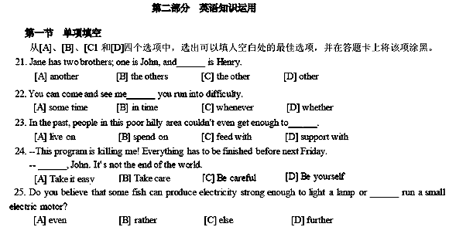
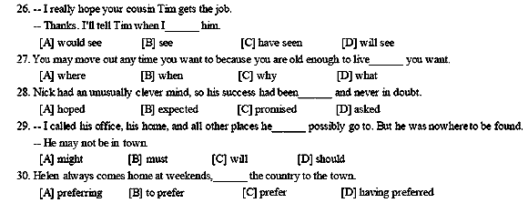
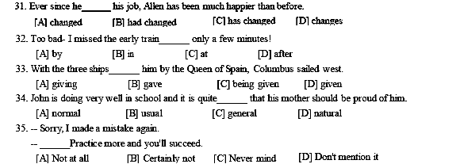
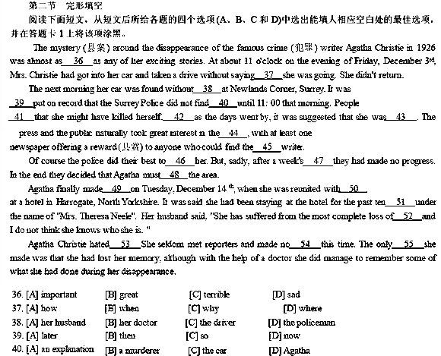
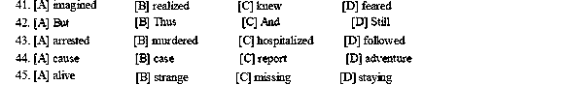
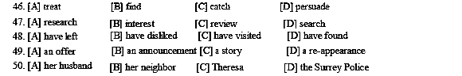
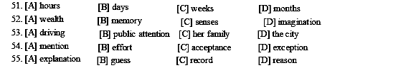
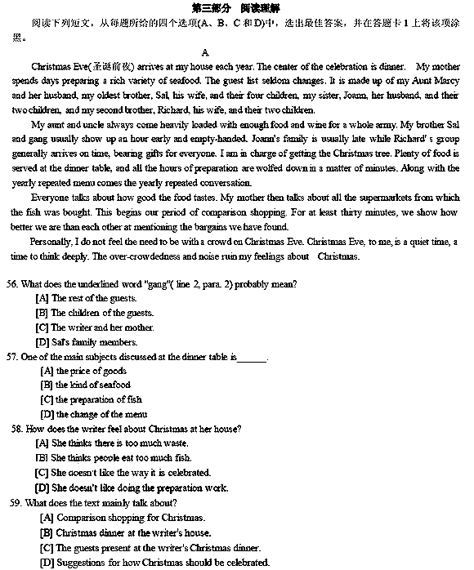
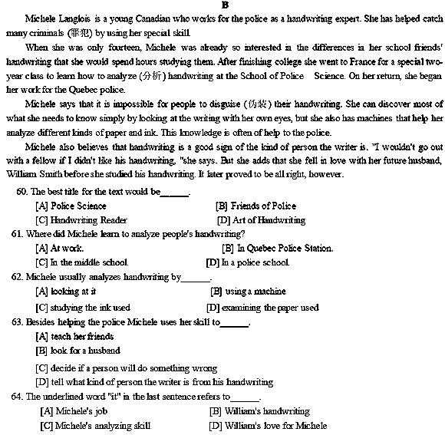
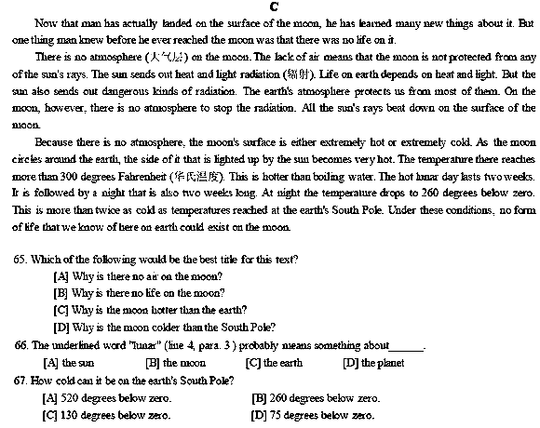
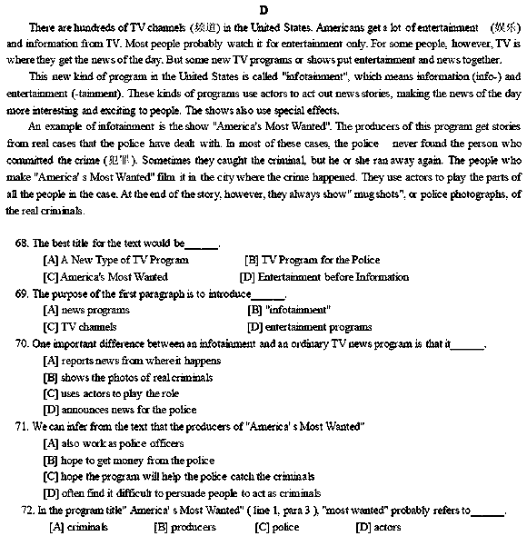
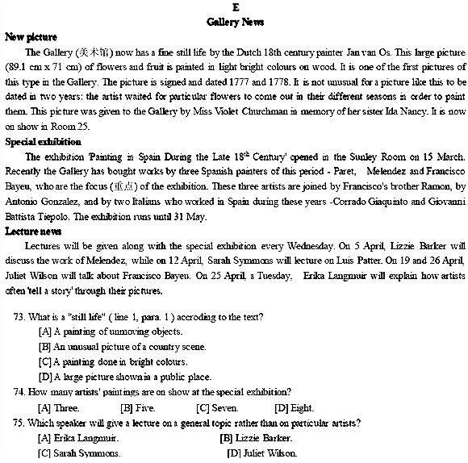
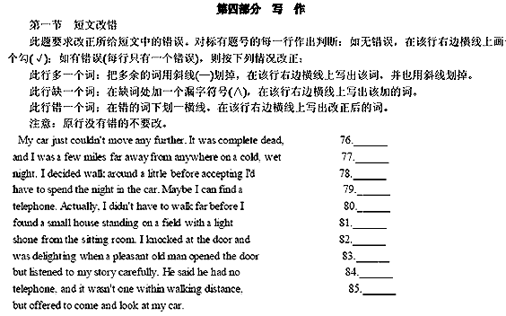
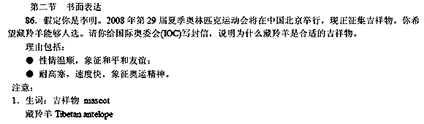
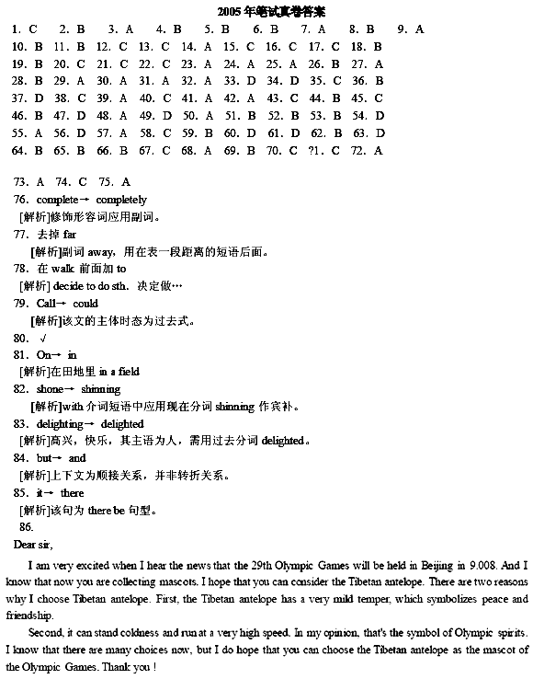
06年3月全国英语等级考试二级真题
2006年3月英语等级考试(PETS)二级笔试参考答案
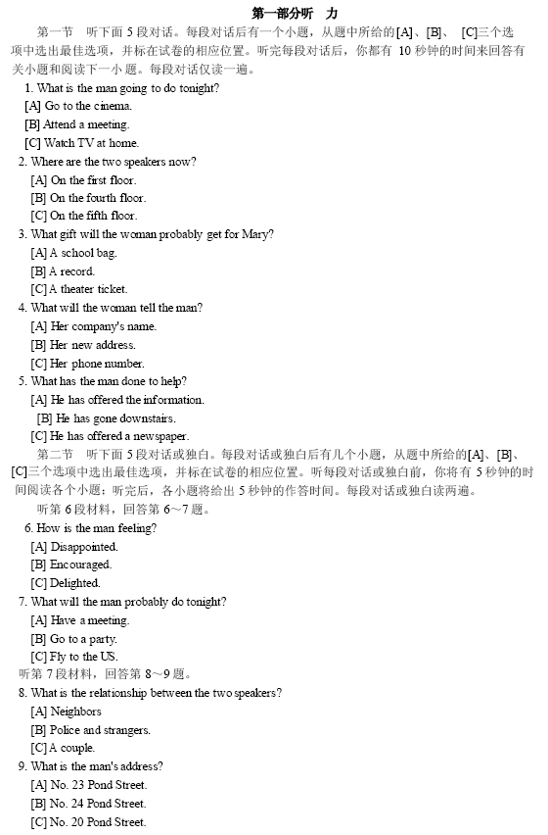
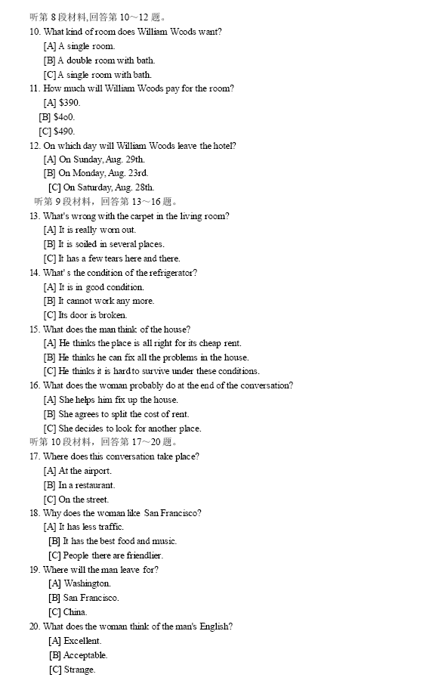
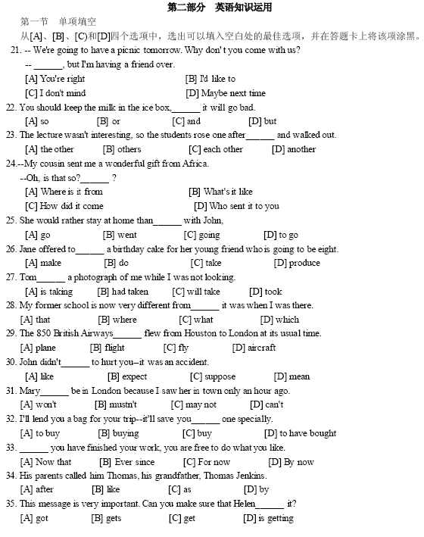
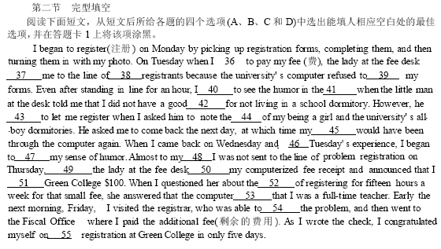
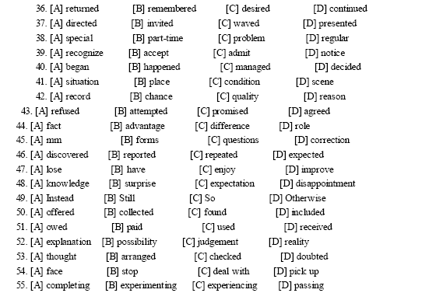

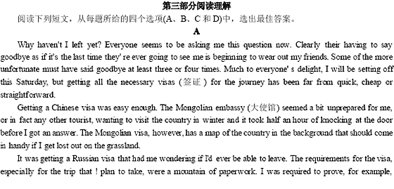
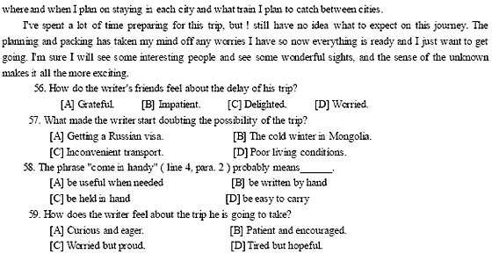
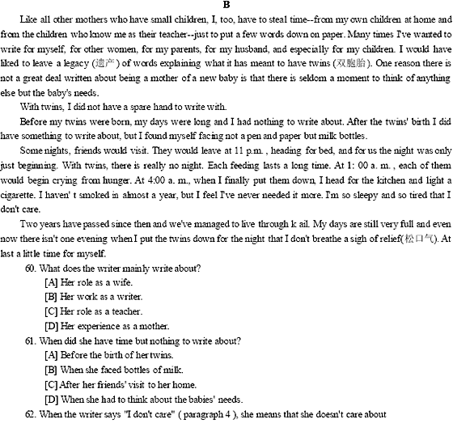
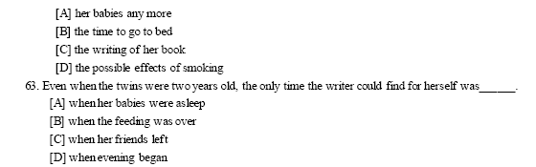
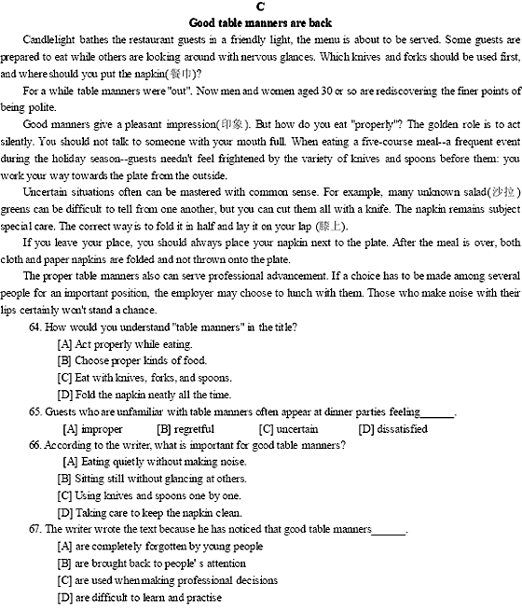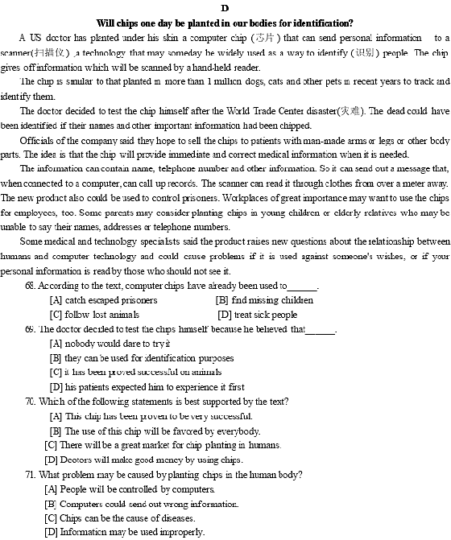
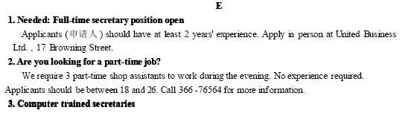
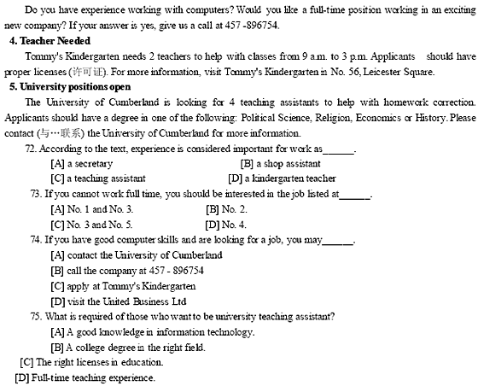
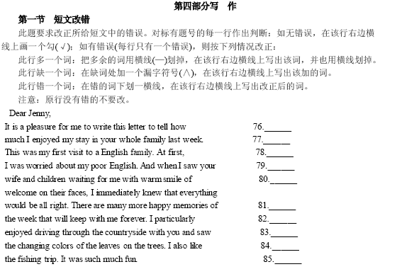
2006年3月英语等级考试(PETS)二级笔试真题
