03年9月全国英语等级考试一级真题
笔试部分答题时间：70分钟
姓名： 准考证号：
第一部分 听 力 1～25略
第二部分 英语知识运用
第一节 单项填空
阅读下面的句子和对话，从A.、B.、C.三个选项中选出一个能填入空白处的最佳选项，并在答题卡1上将该项涂黑.
例： Bob and I made __________ agreement last Monday.
A.a B.an C.any
答案：B.
26. The floor of his living-room is __________ pieces of paper.
A. covered with B. put on C. filled in
27. Be sure to tell to the horses.
A.don't B.not to C.not
28. Sally __________ in Suzhou and is now fifteen years old.
A. is born B. was born C. has been born
29. I like the film. Its music is __________ .
A. beauty B. beautiful C. beautifully
30. The teacher the class __________ talking.
A. to stop B. stops C. stopped
31.“ You didn't like it, did you?”
"Yes, __________ "
A.I did B.I didn't C.I didn't like it
32. Let me see. Yes, he has __________ moved to New York.
A. still B. already C. yet
33. How much did you __________ for the computer?
A. spend B. cost C. pay
34. They told her the good news __________ they heard it.
A. before B. though C. as soon as
35. There used __________ a bookstore at the comer of the street.
A. to be B. to being C. to have
36. You __________ sick. Is there anything wrong with you?
A. get B. look C. turn
37. The book's written by my brother. Don't you find it __________ .
A. interested B. interesting C. interest
38. Can you help me? I can' t find my key __________ the door anywhere.
A.with B.in C.to
39. Sally must be very sad. She was __________ crying in her bedroom.
A. to see B. seen C. seeing
40. Mary is though she is still __________ her twenties.
A. about B. on C. in
第二节完形填空
阅读下面短文，从短文后所给的A.、B.、C.三个选项中选出能填人相应空白处的最佳选项，并在答题卡l上将该项涂黑.
The doctor looked ( Example:___0___ ) the boy' s throat (喉咙), and listened to his heart.41 he asked Bobby and his mother a few ___42___ .
At last the doctor said, "You' ll be time, my boy. "
"Oh, Doctor! Do you ___43___think so?" Bobby's mother ___44___ very happy.
Dr. Smith answered, "Mrs. Adams, your son has a sickness. ___45___ is very common ( 常见的 ) to boys who like football at a time ___46___ this. It comes and goes very quickly. "
"Today," the doctor told her, "the ___47___ important football game of the year is on television.
___48___ Bobby feels well enough ___49___ television this afternoon, and I think he does, he will be ___50___ when finished. "
41. A. Then B. so C. But
42. A. words B. problems C. questions
43. A. really B. always C. usually
44. A.looks B.has looked C. looked
45. A. There B. This C. He
46. A. like B. as C. of
47. A. much B. more C. most
48. A. Until B. Because C. If
49. A. to watch B. watching C. watches
50. A. sad B.fine C. glad
第三部分阅读理解
第一节词语配伍
从右左栏各项意义相符的选项，并在答题卡l上将该项涂黑.
51. People grow plants or Vegetables there.
52. It is the first meal of the day.
53. People and cars travel on it.
54. It is sweet and drinks.
55. People get on or off planes there.
A. breakfast
B. dinner
C. airport
D. farm
E. hotel
F. sugar
G.road
第二节短文理解
阅读下面短文，从A.(Right)、B.(Wrong)、C.(Doesn’t Say)三个判断中选择一个正确选项，并在答题卡1上将该项涂黑.
I once read a story about a fisherman(渔民)．This fisherman did not go fishing every day．Instead，he often lay on the bank enjoying the sunshine．Someone asked him why he did not spend his time catching more fish SO that he could make mole money and live a mole comfortable(舒适的)life．His answer was：“
I am living a comfortable life!”
I could not help thinking about the lives that many people are used to living．They give all their time to their work．They often sleep little and eat just enough to keep themselves going in order to make and save money day after day．I don’t think that what they do is not fight．but the difference between their life and that very great．
The fisherman may not be very rich，yet it does not stop him from feeling happy．Many of us think that money is the greatest source(源泉)of joy．But if we spend all our time working for it，do we forget how to enjoy the pleasure of life?
56．The story true．
A.Right B.Wrong C.Doesn’t Say
57．According to the writer，the fisherman was living a comfortable life．
A.Right B.Wrong C.Doesn’t Say
58．The story of the fisherman made the writer think about people’s ways of living．
A.Right B.Wrong C.Doesn’t Say
59．The writer doesn’t think much of the fisherman．
A.Right B.Wrong C.Doesn’t Say
60．According to the writer，money of pleasure in life．
A.Right B.Wrong C.Doesn’t Say
第三节短文理解2 阅读下列短文，从A. 、B. 、C. 三个选项中选择一个正确答案，并在答题卡l上将该项涂黑. 请根
据下面短文回答第6l-65题：
Announcement(通知)
Good morning，ladies and gentlemen．May I draw your attention(注意)to the book Safety in flight ?You will find the book in the pocket at the back of the seat in front of you and we ask you to read it．You’11 also find a newspaper and you may find it interesting．For those of you not familiar with this kind of plane，you can smoke side of the passenger cabin(机舱)，once the signs at the front of the cabin have been turned off，and at no time in the toilet at the back I of the plane．We have a duty-free(免税的)bar on the plane and cigarettes，beer and mineral water will be on sale during the flight．If you have any questions during the flight，please ask our four I hostesses(空姐)．Would you now please fasten(系紧)your seat belts to get ready for take-off? We wish you a pleasant flight! Thank you．
61．The announcement is made ．
A. during the flight B. ．before taking off C. after taking off．
62．People are asked ．
A. to read the book Safety in Flight
B. to find out where they can smoke
C. to buy something during the flight
63．Can people smoke in the plane?
A. No，they can’t． B. Yes，but only in some areas of the plane．
c. Yes，but only in the cabin．
64．People in the plane can ．
A. have a good sleep B. have some small girls
C. buy some duty-free things
65．We learn from the text that ．
A. the passengers will have a morning flight
B. they will have meals during the flight
c. the plane is going to fly across a mountain
请根据下面短文回答第66-70题：
When I was 12，something happened(发生)to me that changed my interest．
We lived near a wood and every evening birds would sing beautifully in the trees．1 wanted to catch a young bird and keep it in a cage(鸟笼)SO that 1 would have my own singer．
I did get one and put it in a cage．At first the bird flew about in the cage．but after a while it became quiet in its new home．I felt very happy and some beautiful singing from my little singer．
On the second day，its mother flew to the cage with food．The baby bird ate everything．I was pleased to see this．Surely the mother knew better than 1 what her baby liked．
The next morning，I found the bird dead．What happened? I had taken good care of the bird．or so I thought．
Arthur Wayne told me the reason．“A mother bird，finding her baby in a cage，will sometimes bring it poison berries(毒草莓)．She thinks it is better for it to die than to live in a cage．"
Never since then have I caught any living bird and put it in a cage．
66．The boy wanted to keep a bird in a cage ．
A. So that he could listen to it sing every day
B. because he thought birds liked to live in cages
C. in order to have more birds flying into his house
67．What happened on the third day?
A. The bird got out of the cage．
B. The mother bird came to help her baby．
C. The baby bird was found dead．
68．How did the boy feel when he saw what happened to the bird?
A. He was surprised． B. He was pleased． C. He was angry．
69．What did the the cage for?
A. To end her baby’s life．
B. To bring her baby some food．
C. To sing together with her baby．
70．From the story we know that ．
A. the storyteller liked music very much
B. the storyteller was a bird lover
C. the storyteller is now a boy of 12
第四部分 写作
第一节改写句子
下面是关于我和Peter去购物中心的三对句子.每对句子中，第一句是原句，第二句是对第一句的改写.要根据原句和第二句中已经给出的部分用一至五个单词补全第二句.把补出的部分写到答题卡2上各题的序号后注意不能改变原句的意思.
71. Last I took to a taxi to the shopping center.
Last I went to the shopping center .
72. I bought my father a pair of shoes for forty dollars.
I bought a pair of shoes for my father, and they __________ forty dollars.
73. Peter lent me bought a radio.
I __________ from Peter and bought a radio.
第二节书面表达
74．情景：
你和Peter约好一起外出，可你了.
任务：
请张50词左右的便条.内容包括：
你因何不能去；
建议何时再去；
你们如何再联系.
04年9月全国英语等级考试一级真题
笔试部分答题时间：70分钟
姓名： 准考证号：
第一部分听 力1～25略
第二部分英语知识运用
第一节单项填空
阅读下面的句子和对话，从A.、B.、C.三个选项中选出一个能填人空白处的最佳选项，并在答题卡l上将该项涂黑.
26. If you soon catch__________the other students.
A.out of B.on to C.up with
27. We____________a nice talk about the plan yesterday morning.
A. had B. have C. having
28. There are about the class, but Mike is____________ strongest.
A.a B.an C.the
29. Decide for yourself. This one __________ that one?
A. but B. or C. nor
30. It __________ when he got up.
A. is snowing B. was snowing C. has snowed
31. There' s still quite a lot to go round, __________ you like some more?
A. Should B. Could C. Would
32.-What will you do tomorrow ?
-I'll go __________ tomorrow.
A. fishing B.fish C.to fish
33. I don' t need any help. Mind __________ own business, please.
A. my B. one' s C. your
34. He __________ into the office building when the fire bell rang.
A. was going B. goes C. has gone
35. The suggestion __________ all right.
A. sounds B. is sounded C. has sounded
36. Just a moment. I'll go as I __________ my face.
A. will wash B. shall wash C. have washed
37. It is very important, __________ you or I must do it.
A. Neither B. Both C. Either
38. How careless he was! He __________ a lot of important ideas while reading.
A. kept B. missed C. passed
39. I had a bad cold last Monday, and so I __________ in bed all day.
A. lay B. lie C. lied
40. __________ I've read this book, you can have it.
A. Though B. Until C. Since
第二节完形填空
阅读下面短文，从短文后所给的A.、B.、C.三个选项中选出能填人相应空白处的最佳选项，并在答题卡l上将该项涂黑.
Joe was road (Example: 0 ) one night. Suddenly 41 became wrong with his car wheel(轮胎). He did not know 42 to do and, worse still, he did not have a 43 wheel with him! Joe 44 to passing cars, but them stopped.
At last, he tried a car just 45 his own. To his surprise, the car stopped and a' young 46 got out.
Joe felt hopeless 47 he didn' t think she could help him. The lady, 48 , gave him her own spare wheel, but that he had never changed a wheel in his life! She began to work 49 and fitted(安装) the wheel 50 a few minutes.
41. A. something B. anything C. nothing
42. A. how B.what C. where
43. A. useful B. second C. spare
44. A. said B. spoke C. shouted
45. A.as B. like C. for
46. A. man B. woman C. people
47. A. but B. though C. because
48. A. but B. however C. for example
49. A. at once B. at first C. at last
50. A. in B. after C. about
第三部分阅读理解
第一节词语配伍
从右栏所给选项中选出与左栏各项意义相符的选项，并在答题卡1上将该项涂黑.
51. People go there to borrow books,
52. People get on and off a train there.
53. People must have it to go abroad.
54. People information. 55. People use it to find their way.
A.newspaper
B.airport
C.map
D.railway station
E.passport
F.post office
G.library
第二节 短文理解1
阅读下面短文，从A.(Right)、B.(Wrong)、C.(Doesn’t say)三个判断中选择一个正确选项.并在答题卡l上将该项涂黑.
The poor little girl was tired and hungry in the forest(森林). She walked through the forest, hoping to find something to eat because she didn' t want to die. Then she found a little house and thought it must be a woodman's( 伐木人的) house and she might be able to stay there. So she knocked at the door.
As there was no answer, she opened it and went inside.
There she saw a room with a long table. On it there were seven knives and forks, seven plates and drinking cups, and on the plates and in the cups were food and drink. The little girl was too hungry to turn away from the food, so she took a little from each plate and each cup.
At the other end of the room, there were seven little beds. She tried to lie on some of them, and when she found a very nice one, she fell into a deep sleep, for she was very tired after a long walk through the forest.
56. The little girl was happy to get to the forest.
A.Right B.Wrong C.Doesn't say
57. When she got to the little house, someone opened the door to let her in.
A.Right B.Wrong C.Doesn't say
58. There were no more than seven people living in the house. In the house she found a few things for seven people.
A.Right B.Wrong C.Doesn't say
59. The room was the home of some short kind-hearted men.
A.Right B.Wrong C.Doesn't say
60. The little girl slept very little beds.
A.Right B.Wrong C.Doesn't say
第三节短文理解2
阅读下列短文，从[A]、[B]、[C]三个选项中选择—个正确答案，并在答题卡l上将该项涂黑.
请根据下面短文回答第6l－65题：
Henry Richardson is working in an important library. His job is to give new life to old books. Many of these books are very old or are the one and only copy in the world.
Richardson has saved(挽救) the lives of many books. His first job is to wash the pages. He takes off the old cover, and places each page in water. Then he carefully puts each one between sheets(纸张) of paper to dry. Some of the pages may be very thin or have missing parts. Richard-son mends these while they are still wet. He places each one on a heavy sheet(块) of glass. Then he carefully puts small pieces of paper on the places which need mending. These pieces of paper are very thin. They look like part of the old paper.
The washed pages clean. The pages are put together again in the old cover.
At times, only the from and back parts of the old cover can be used. Sometimes a whole new cover must be made. Now the stronger, cleaner, and "newer" book is returned to the library, once again ready for use.
61. Why should old books be saved?
A. Because they give us a lot of information.
B. Because they are very interesting:
C. Because they may be the only copy.
62. To save old books, Richardson first .
A. places the wet pages on a sheet of glass
B. washes the pages C. mends the cover
63. To dry the wet pages, Richardson .
A. leaves them in the sun
B. places them on a sheet of glass
C. puts them between sheets of dry paper
64. The old cover of the book .
A. must be used B. is sometimes used
C. should never be used
65. Richardson mends old books .
A. in a hospital B. in a library C. at home
请根据下面的短文回答第66－70题：
The Maryland Science Center is more than fun. You can enjoy the three floors of exciting things, watch the larger-than-life play on the 4th floor, and travel to other worlds, to far away stars, on the 5th floor.
Don' t just look. You are expected to feel, to turn, to push. Build your own house and learn why it stands or falls. Use computers to work out plans just as famous scientists have done. There is always something new to learn at the Maryland Science Center.
Children and group visitors enjoy half price.
The Maryland Science Center does not end when you leave. Visit the Science Store for a gift you' d like to keep. Electronic jewelry( 电子珠宝), games, books, and more --take part of the Science Center .home with you.
Information
Where to call:
24 hour general(常规的) information(410)685-5225
24 hour STARLINE night sky information (410)539-STAR
Group visitor information (410) 685-2370
Hours:
The Maryland Science Center is open 7 days a week (except Thanksgiving Day and Christmas
Day )
Monday－Friday 10 a. m. -6 p. m.
Saturday and Sunday 10 a. m. -8 p. m.
66. What can visitors do at the Maryland Science Center?
A. Learn science by trying it out.
B. Watch and take part in a play.
C. Make gifts for their friends.
67. The Maryland Science Center stays open .
A.every day from 10 a.m. to 8 p.m.
B. almost all the weekdays and weekends
C. on Thanksgiving Day and Christmas Day
68. By calling (410)685-2370 we can get information about .
A. the night sky show B. books and games
C. group price tickets
69. "Take part of the Science Center home with you" means that .
A. visitors can buy something there and take them home
B. the Science Center may be sold to visitors
C. the visitors can make the Science Center their home
70. Which Maryland Science Center?
A. Visitors can play and learn, at the same time.
B. It helps visitors travel to other countries.
C. It can be visited 24 hours a day.
第四部分 写作
第一节改写句子
下面是关于Mary的朋友请她陪伴上街购物的三对句子.每对句子中，第一句是原句，第二句是对第一句的改写.要求根据原句和第二句中已经给出的部分用一至五个单词补全第二句，把补出的部分写在答题卡2上各题的序号后.注意不能改变原句的意思.
71. My friend said to me, "Are you free?"
My friend asked me if __________ ,
72. She shopping with her.
I __________to her.
73. She thinks it a pleasure to a friend.
She thinks that __________ a pleasure to a friend.
第二节 书面表达
74．情景：
一位外国客人乘出租汽车去机场，下车时将一个皮包忘在了车上.
任务：
写一事，内容包括：
所发生的事；
希望找到失主；
如何联系.
05年3月全国英语等级考试一级真题
第二节完形填空
阅读下面短文，从短文后所给的A.、 B.、 C. 三个选项中选择能填入相应空白处的最佳选项，并在答题卡1上将该项涂黑。
It (Example:40) 8 o’clock 41，and the last bus 42 at the second bus stop.A middleaged woman got out,and the conductor was going to ring the bell for 43 to start the bus again,just at saw a small child 44 at the bus stop.
“What’s wrong with you?” the bus conductor said to the boy.
“Well,my mother gave me ten pence to go home by bus after school,but I 45 the money after I finished playing football with my classmates,” the child answered, “so I have to walk all the way home.”
“That’s OK.” said the conductor. “Come on.We’ll take you home.”
The child thanked him, 46 the bus and sat down near the door.The bell,then the bus started. “How 47 are you living?” asked the conductor.
The child told him the name of the place where he lived.It was about two miles away,and 48 would have cost him two pence if the child had had the money to pay for it.
The conductor went to give some other people on the bus their tickets,and when he came back a few minutes 49 ,he saw that child crying again.
“And what’s the matter with you now?” he asked. “Aren’t you on your way home?”
“Yes,I am,” answered the child, “but what about my change?You to me,have you?You should give me 50 .”
例：40.A. is B. are C. was
答案： C.
41.A.in the morning B.in the afternoon C.at noon
B
42.A.just had left B.have just left C.has just stopped
C
43.A.the driver B.the conductor C.the old woman
A
44.A.to cry B.crying C.to be crying
B
45.A.had forgot B.has dropped C.lost
C
46.A.got on B.got up C.getting on
A
47.A.long B.far C.soon
B
48.A.the seat B.the chair C.the ticket
C
49.A.later B.late C.after
A
50.A.ten pence B.eight pence C.two pence
B
第三部分阅读理解
第一节词语配伍从右栏所给选项中选出与左栏各项意义相符的选项，并在答题卡1上将该项涂黑。
例：They guard the exits.
答案：E.
51.People cook food here.
52.You can sit on it.
53.People can buy things here.
54.Someone day.
55.Children like to go there.
A.shop
B.park
C.birthday
D.restaurant
E.school
F.kitchen
G.chair
答案为：
51、F
52、G
53、 A
54、C
55、 B
第二节短文理解1
阅读下面短文，从A. (Right)、 B. (Wrong)、 C. (Doesnt Say)三个判断中选择一个正确选项，并在答题卡1上将该项涂黑。
It must have been about two in the morning when I returned home.I tried my best to wake up my wife by ringing the doorbell,but she was fast asleep,so I got a ladder from a shed in the garden,put it against the wall,and began climbing towards the bedroom window.I was almost there when I heard someone saying, “I don’t need cleaning at this time of the night.” I looked down and nearly fell off the ladder when I saw a policeman.I regretted answering in the way I did at once,but I said, “I like cleaning windows at night.”
“So do I,” answered the policeman in the same tone, “excuse my interrupting(打扰) you.I hate to interrupt a man when he is busy working,but would you mind coming with me to the station?”
“Well,I’d prefer to stay here,” I said, “you see,I’ve forgotten my key.”
“Your what?” he called.
“My key,” I shouted.
Luckily,the shouting woke up my wife who opened the window just as the policeman had started to climb towards me.
56.I didn’t come home until my wife went to bed.
A.Right. B.Wrong. C.Doesn’t say.
A
57.I couldn’t wake up my wife because there was something wrong with the doorbell.
A.Right. B.Wrong. C.Doesn’t say.
B
58.The policeman didn’t believe me.
A.Right. B.Wrong. C.Doesn’t say.
A
59.The policeman didn’t trouble me for I was busy.
A.Right. B.Wrong. C.Doesn’t say.
B
60.If the up my wife,the policeman would take me away.
A.Right. B.Wrong. C.Doesn’t say.
A
第三节短文理解2
阅读下列短文，从A.、 B.、 C. 三个选项中选择一个正确答案，并在答题卡1上将该项涂黑。
请根据下面短文回答第61～65题：
Mrs.Wang was seventy eight years old.Her husband worked in a post office.The next year her husband had a long holiday.So they made a journey to another city,their bus hit a rock and began to burn.The husband broke the window and helped his wife get off,but he died in the burning bus.And now the old woman has lived a lonely life for 6 years.She often walks near the garden or sits on a chair quietly.She had a dog and liked it very much.But she lost it one morning.
Yesterday afternoon,Mrs.Wang was sitting on a chair near the garden while a her with a dog.The old woman saw the lovely dog and asked the boy, “Does your dog bite?”
“No,it doesn’t,” answered the boy.
Having heard this,the old woman began to touch its head.Suddenly it bit her hand and she began to shout at the boy, “Why did you fool me?”
“I’ve never fooled you,madam,” said the boy. “My dog doesn’t bite anybody,but that dog isn’t mine!”
61.Where did Mr.Wang work?
A.He worked in a company.
B.He worked in a post office.
C.He worked in another city.
B
62.Why does the old woman often sit near the garden?
A.Because she feels lonely. B.Because she is free.
C.Because she can’t do anything.
A
63.Which sentence is wrong?
A.Mr.Wang and his wife went on a journey to another city in their own car.
B.Mr.Wang died in the accident.
C.The old woman was saved in the accident.
A
64.From the passage,we can know that.
A.Mrs.Wang loved the dog very much
B.Mrs.Wang got out of the fire herself
C.Mr.Wang was not careful enough
A
65.The boy .
A.is a kind boy B.fooled the old woman
C.didn’t know whose dog it was
C
请根据下面的短文回答66～70题:
Last Saturday,after doing all the family shopping in town,I wanted to have a rest before catching the train.So I bought some chocolate and a into the station coffee shop with a long table to sit at.I put my heavy bag down on the floor,put the newspaper and chocolate on the table to keep a place,and went to get a cup of coffee.
When I came back with the coffee,there was someone sitting next to me.It was one of those
strangelooking young men,with dark glasses,old clothes and long hair.But I wasn’t surprised at such a young man.What surprised me most was that he had started to eat my chocolate!
I was quite uneasy about him,but I didn’t want to get him into trouble.I just looked down at the front page of the newspaper and took a bit of the chocolate.The boy looked at me. Then he ate a second piece of the chocolate.Still I didn’t say anything.When he ate a third piece,I felt a bit angry.I thought, “Well,I shall have the last piece.” And I got it.
The boy looked at me strangely,then stood up.As he left,he shouted out, “This woman is mad!”
Everyone looked at me.That was embarrassing(尴尬的) enough.But it was worse when I finished my coffee and got ready to leave.My face turned red when I found I had made a mistake.
It wasn’t my chocolate I had eaten.Mine was just under my newspaper.
66.Why did the woman go to the town?
A.To do some shopping. B.To drink coffee.
C.To buy some chocolate.
A
67.Why was the woman surprised when she came back with the coffee?
A.Because she saw a strange young man with dark glasses.
B.Because the young man started to eat her chocolate.
C.Because a young man sat in her seat.
B
68.Where was the woman’s chocolate?
A.It was eaten by the young man.
B.It was eaten by the woman.
C.It was under the newspaper.
C
69.Who was angry?
A.The young man. B.The woman. C.Both of them.
C
70.The woman found her mistake.
A.when leaving
B.after she left the shop
C.just before she left the coffee shop
C
第四部分写作
第一节改写句子下面是三对句子。每对句子中，第一句是原句，第二句是对第一句的改写。要求根据原句和第二句中已经给出的部分补全第二句，把补出的部分写到答题卡2上各题的序号后。注意不能改变原句的意思。
71.To make a big not polite.
It’s polite toin the library.
72.I don’t like milk so much as orange.
I like orangemilk.
73.Both health.
of themin good health.
正确的答案：
71.keep quiet
72.better than
73.Neither...is
第二节书面表达
74情景：
假如你是王涛，你的美国笔友Peter来假。
任务：
请你用英语给他写一封50字左右的回信。内容包括：
(1)欢迎他来北京。
(2)恰好你也有一个月的假期。
(3)在北园、长城等。
(4)去机场接他。
便条写在答题卡2上该题的序号后。请用下面格式：
Peter，
…
Wang Tao
05年9月全国英语等级考试一级真题
第二部份 英语知识运用
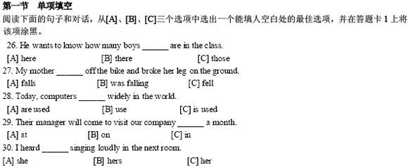
26、B 27、C 28、A 29、 C30、C
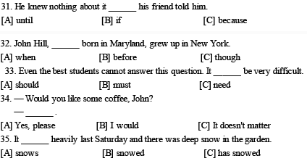
31、A 32、C 33、B 34、A 35、B
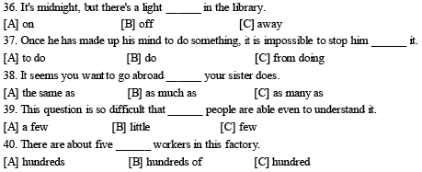
36、A 37、C 38、A 39、C 40、C
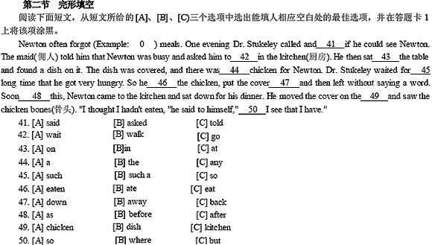
41、B 42、B 43、C 44、B 45、B
46、B 47、C 48、C 49、B 50、C
第三部份 阅读理解
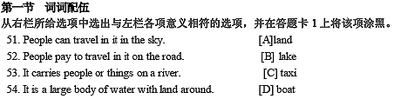
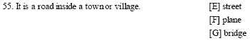
51、F 52、C 53、D 54、B 55、E
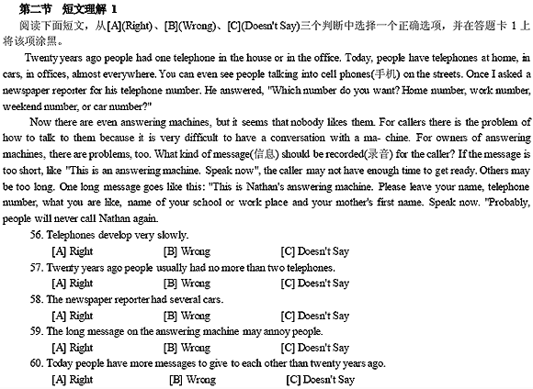56、B 57、A 58、C 59、A 60、C
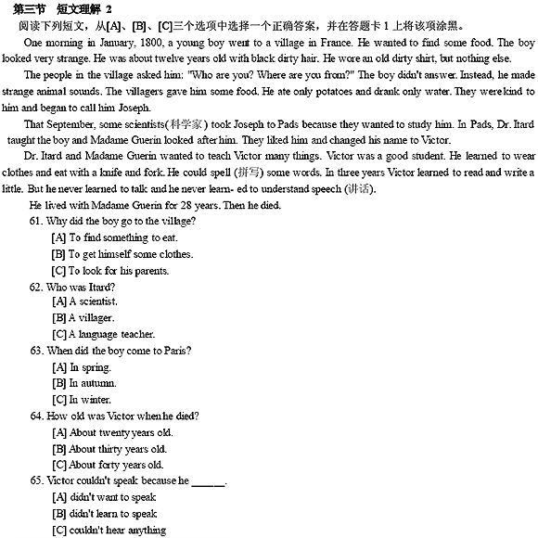61、A 62、A 63、B 64、C 65、B
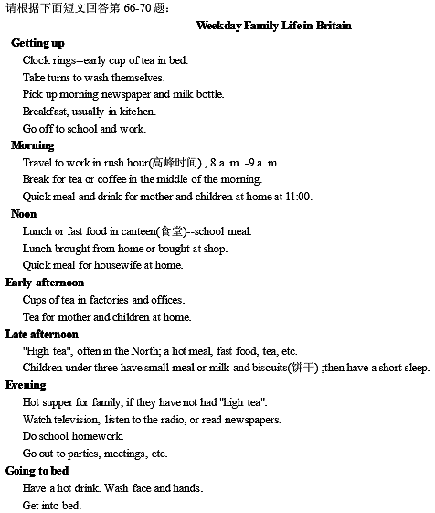
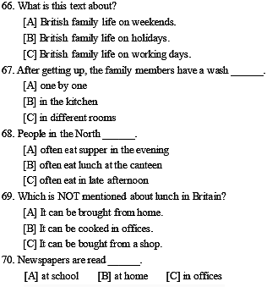
66、C 67、A 68、C 69、 B70、B
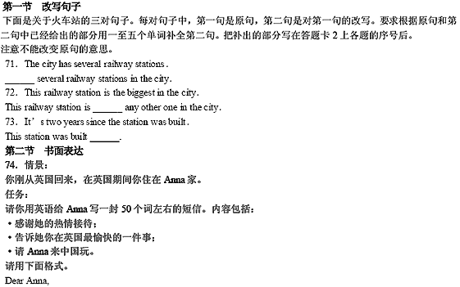
71、There are
72、bigger than
73、two years ago
74、范文：
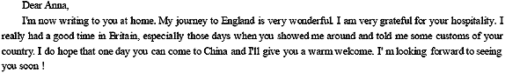
06年3月全国英语等级考试一级真题
第二部份 英语知识运用
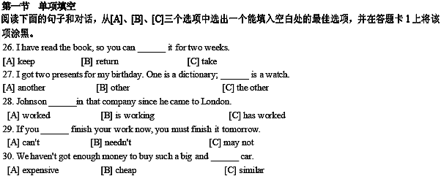
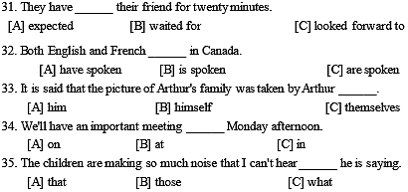
26、A 27、C 28、C 29、A 30、A 31、B 32、C 33、B 34、A 35、C
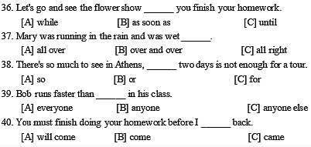
36、{bb] 37、 A38、A 39、C 40、B
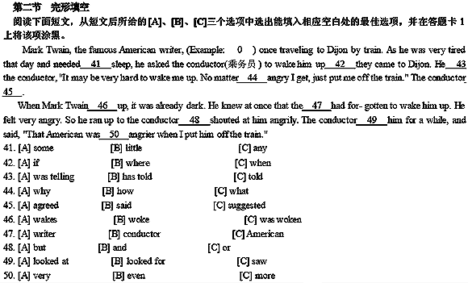
41、 A42、C 43、C 44、B 45、A
46、B 47、B 48、B 49、A 50、B
第三部份 阅读理解
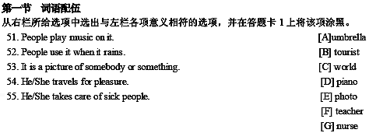
51、D 52、A 53、E 54、B 55、G

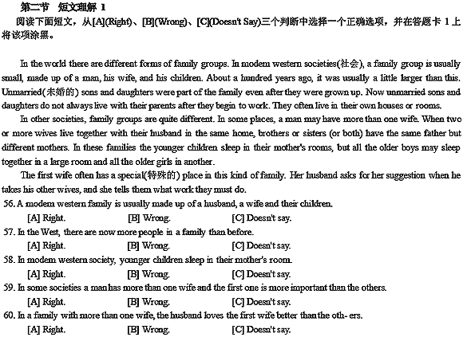56、A 57、B 58、B 59、A 60、C
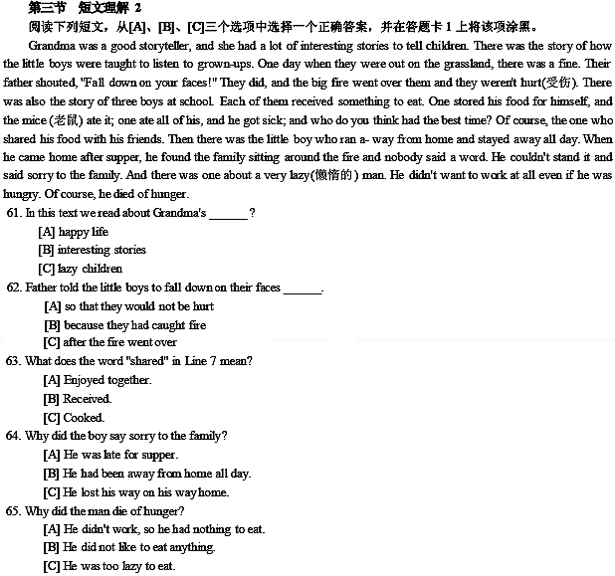61、 B62、A 63、A 64、B 65、A
第四部份 写作
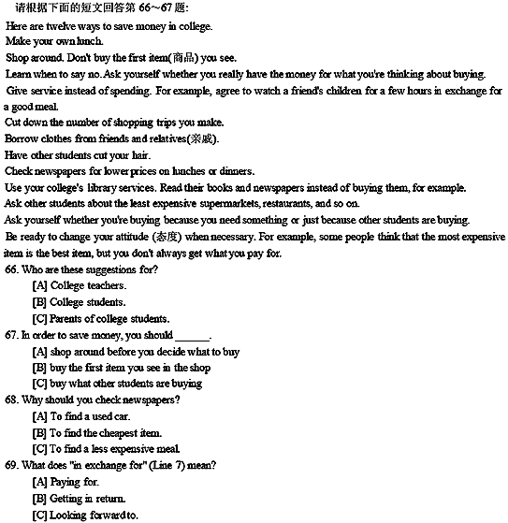
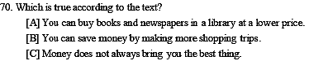
66、 B67、A 68、C 69、B 70、C
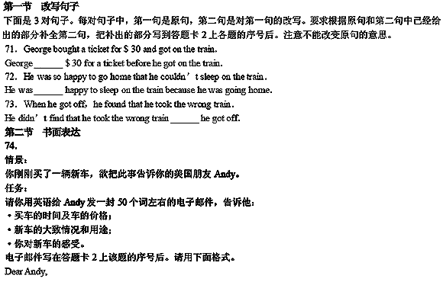
LiMin
71、paid
72、too
73、until
74、范文：
